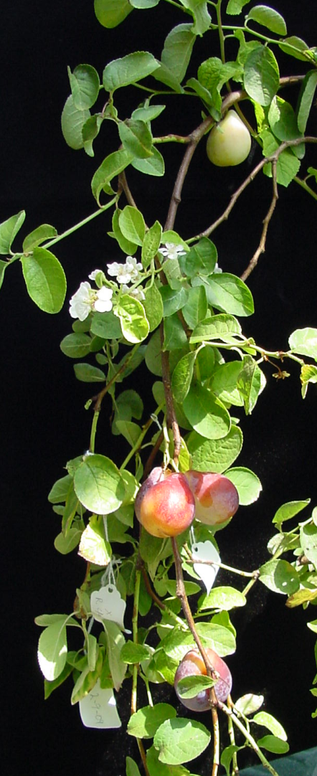
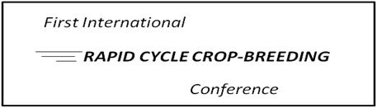

January 7-10, 2014
The National Conference Center, Landsdowne, Virginia
Now more than ever, there is a need to rapidly improve perennial crops to meet the challenges of climate change, scarcity of labor, the desire for reduced chemical inputs, the spread of exotic pests and pathogens, and increasing demands for product quantity and quality. Yet breeding of these long-generation-cycle crops remains a slow, arduous process that has changed little over time. Research has focused on marker assisted selection, germplasm characterization, and genetic engineering as means to advance breeding, and significant successes have been achieved. However, the successes of these strategies are still limited by lengthy generation cycles. There is a critical need for the development of systems to reliably shorten breeding cycles in order to take full advantage of advances in genetic knowledge for crop breeding. This conference seeks to gather experts in the fields of plant breeding, genetics, molecular biology, horticulture, forestry, plant physiology and related fields to discuss approaches and present the latest findings related to the shortening of breeding cycles in long-generation cycle crops in order to more efficiently and effectively face the challenges of improving the world’s production of food and fiber.

The meeting will consist of two days of invited and contributed talks, round table discussions and posters; a half-day excursion to view a rapid cycle breeding program; and a half-day program on interacting with the public on Biotechnology.

Keynote Speakers include: Bert Abbott, Sue Gardner, Pace Lubinsky, Magda-Viola Hanke, Leandro Pena, Ralph Scorza and Steve Strauss.
Reservations Process & Booking Website: https://resweb.passkey.com/go/usda27929
Registration: Due November 1st, 2013 https://resweb.passkey.com/go/usda27929

Abstracts: Due October 1st, 2013 for consideration for oral presentations
Submit abstracts to rapidcyclecropbreeding@yahoo.com

Further information is on our website: http://www.ars.usda.gov/SP2UserFiles/Place/19310505/RCCB%20Conference.docx

Conference funded through NIFA-SCRI grant #2009-51181-06011

