RosCAP proposal committee structure:
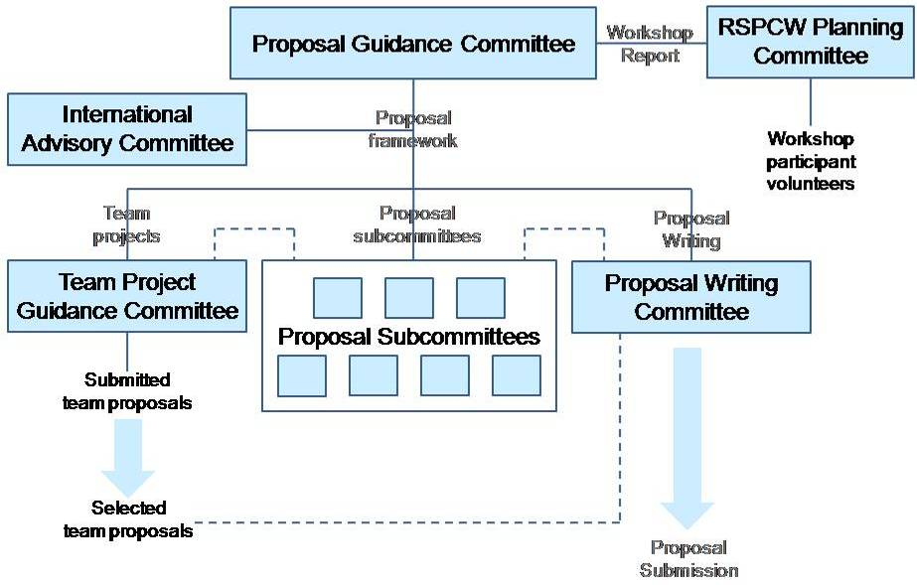

RosCAP 4-year outline:
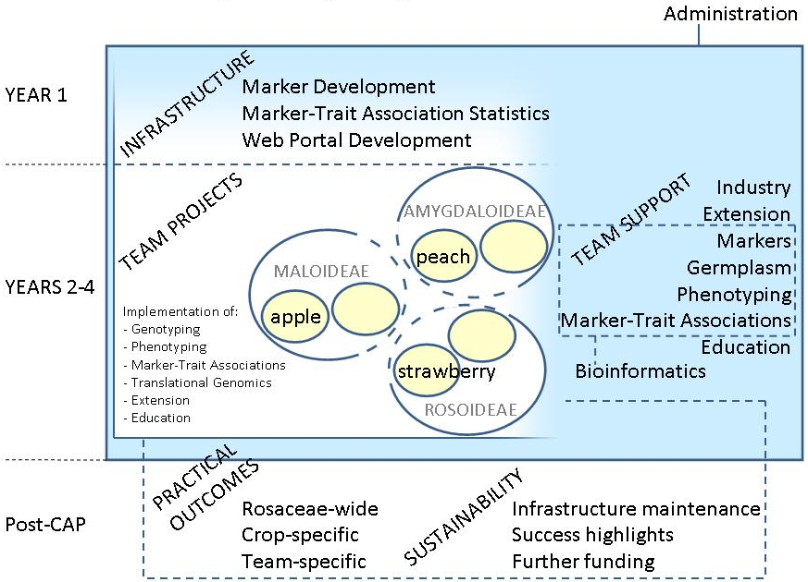

Team Project Guidance Committee
Co-chairs: Chris Dardick and Amy Iezzoni
Other members: [interested US and international Rosaceae GGB people, at least one person for each subfamily that is fully knowledgeable in industry issues, several non-Rosaceae people] Schuyler Korban, Eric van de Weg,
Tasks:
- DONE: Outline the details of what Team Projects entail
- DONE: Prepare and disseminate a Call for RosCAP Team Pre-proposals (pre-proposals from community are due Oct 14)
- Enlist several non-Rosaceae people to help review pre-proposals
- Establish subfamily subcommittees (Rosoideae, Maloideae, Amygdaloideae) to help in reviewing and guiding individual team projects
- Review submitted pre-proposals and decide teams to be developed further
- Notify the community of successful team pre-proposals to be taken forward: Oct 31
- Facilitate development of the Team Project proposals by guiding the various teams through frequent communication with team project PIs
- Work with individual chosen teams during November and December to develop the specific projects to be included in the full RosCAP proposal (want to complete this before 2008 so as not to overlap with major efforts in the community to develop NRI proposals)
- Provide a basic plan to the Proposal Writing Committee at the end of November so that a clear, well-defined letter of intent that highlights the principle components can be written
- Provide written descriptions, budgets, etc, of the team projects to the Project Writing Committee for inclusion in the full RosCAP proposal
- Coordinate closely with most other proposal committees/subcommittees to ensure that team project objectives and activities are aligned with the infrastructure and support ideas being developed in those other committees

International Advisory Committee
Co-chairs: Cameron Peace
Other members: Sue Gardiner, Herman Silva, Pere Arus, Eric van de Weg, Dan Sargent, Luca Gianfranceschi, Elisabeth Dirlewanger, Jasper Rees, and US people – Bert Abbott, , …
Tasks:
- Help ensure “global coordination”
- Advise in most areas of RosCAP proposal preparation, coordinating with other proposal committees/subcommittees
- Coordinate collaborative efforts between the US-led RosCAP and non-US entities to be included in the proposal
- Obtain letters of support from international partners for inclusion in the proposal

Proposal Writing Committee
Co-chairs: Bert Abbott, …
Other members: Amy Iezzoni, Tom Davis, Cameron Peace, Schuyler Korban …, at least one person from each of the subcommittees below Eric van de Weg
Tasks:
- Submit Letter of Intent by the deadline of Nov 26
- Identify the various written components required for the RosCAP proposal
- Write or obtain from others all written components of the proposal

Marker Development and Genotyping Subcommittee
Co-chairs: Tom Davis and Sue Gardiner
Other members: Amy Iezzoni, Gennaro Fazio, Cameron Peace, Herman Silva, Eric van de Weg , Schuyler Korban, Lee Meisel, Pere Arus …
Tasks:
- Determine the technology/approach most appropriate for developing Rosaceae-wide markers within the first year of the project, and what would continue in subsequent years
- Determine the technology/approach most appropriate for developing trait-specific markers following QTL identification for use in breeding
- Determine the activities, costs, timing, and other logistics required concerning marker development and genotyping during the first year of infrastructure development and during the second through fourth years as team support and establishing a sustainable infrastructure
- Contingencies: describe alternative approaches for achieving the objectives within the RosCAP project
- Identify opportunities for incorporating the whole genome sequences of apple and peach into RosCAP
- Decide how and where genotyping will be done for team projects within RosCAP
- Coordinate with the Marker-Trait Associations proposal subcommittee to ensure markers developed are appropriate for pedigree genotyping and other statistical approaches adopted for RosCAP
- Coordinate with the Sustainability Beyond CAP proposal subcommittee to determine the long term value of the markers developed, and to decide how to handle one or more ongoing genotyping centers
- Provide a preliminary basic plan to the Proposal Writing Committee in mid November so that a clear, well-defined letter of intent that highlights the principle components can be written
- Write appropriate sections of the proposal concerning marker development and genotyping for inclusion in the full RosCAP proposal

Germplasm and Phenotyping Subcommittee
Co-chairs:
Other members: Gayle Volk, Cameron Peace, Nahla Bassil, Eric van de Weg…
Tasks:
- Identify germplasm (mapping populations, cultivars, breeding populations, and germplasm collection accessions) available for inclusion in RosCAP
- Determine the possibilities for cross-crop (preferably Rosaceae-wide) phenotyping
- Coordinate with the Team Project Guidance Committee to help determine additional germplasm and phenotyping to enhance individual team projects and enhance connections between team projects
- Provide a preliminary basic plan to the Proposal Writing Committee in mid November so that a clear, well-defined letter of intent that highlights the principle components can be written
- Write appropriate sections of the proposal concerning germplasm and phenotyping for inclusion in the full RosCAP proposal

Marker-Trait Associations Subcommittee
Co-chairs:
Other members: Cameron Peace, Eric van de Weg, Marco Bink, Nnadozie Oraguzie,…
Tasks:
- Determine the requirements for pedigree genotyping so that it is available for individual RosCAP team projects by the start of the second year of the RosCAP project
- Determine the activities, costs, timing, and other logistics required concerning marker-trait associations during the first year of infrastructure development and during the second through fourth years as team support and establishing a sustainable infrastructure
- Contingencies: describe alternative approaches for achieving marker-trait association needs within the RosCAP project
- Coordinate with the Marker Development and Genotyping proposal subcommittee to ensure markers developed are appropriate for pedigree genotyping and other statistical approaches adopted for RosCAP
- Coordinate with both the Extension and Outreach and the Sustainability Beyond CAP proposal subcommittees to ensure that pedigree genotyping can be readily adopted by other Rosaceae breeding programs during and after the RosCAP term
- Provide a preliminary basic plan to the Proposal Writing Committee in mid November so that a clear, well-defined letter of intent that highlights the principle components can be written
- Write appropriate sections of the proposal concerning marker-trait associations for inclusion in the full RosCAP proposal

Web Portal Development Subcommittee
Co-chairs:
Other members: Dorrie Main, Ross Crowhurst, Marc Lateur, Herman Silva …
Tasks:
- Start filling the roscap.org website with RosCAP descriptions and summary of activities and/or modify the GDR to either become the RosCAP site or include a dedicated RosCAP webpage.
- Determine what the RosCAP web portal should look like, essential elements, flowchart that includes both internal and public data access, retrieval, processing, and updating.
- Contingencies: describe alternative approaches for achieving a suitable web portal for the RosCAP project
- Provide a preliminary basic plan to the Proposal Writing Committee in mid November so that a clear, well-defined letter of intent that highlights the principle components can be written
- Complete a basic web portal covering current RosCAP proposal activities by Nov 26 (i.e. by the time Letter of Intent is submitted)
- Write appropriate sections of the proposal concerning web portal development for inclusion in the full RosCAP proposal

Bioinformatics Subcommittee
Co-chairs:
Other members: Dorrie Main, Angela Baldo, Ross Crowhurst, Herman Silva …
Tasks:
- Identify the bioinformatic tools needed to carry out all RosCAP activities
- Create a plan to use existing tools and develop new ones if necessary
- Design a flowchart for data acquisition, management, processing, delivery, and post-delivery support
- Coordinate with the Web Portal Development proposal subcommittee to ensure that planned bioinformatics are readily hosted and accessible within the RosCAP web portal
- Contingencies: describe alternative approaches for achieving bioinformatics needs within the RosCAP project
- Provide a preliminary basic plan to the Proposal Writing Committee in mid November so that a clear, well-defined letter of intent that highlights the principle components can be written
- Write appropriate sections of the proposal concerning bioinformatics for inclusion in the full RosCAP proposal

Education Subcommittee
Co-chairs:
Other members: Bert Abbott, Jim Hancock, Bryon Sosinski, Renea Hardwick, Amit Dhingra, Schuyler Korban, Chris Dardick, Michael McMannis (NZ).
Tasks:
- Define the Education activities to be included in the RosCAP proposal
- Identify appropriate and willing people to carry out activities
- Coordinate closely with the Web Portal Development proposal subcommittee
- Coordinate closely with the Sustainability Beyond CAP proposal subcommittee
- Contingencies: describe alternative approaches for achieving education needs within the RosCAP project
- Provide a preliminary basic plan to the Proposal Writing Committee in mid November so that a clear, well-defined letter of intent that highlights the principle components can be written
- Write appropriate sections of the proposal concerning education for inclusion in the full RosCAP proposal

Extension and Outreach Subcommittee
Co-chairs: Terence Robinson
Other members: Bert Abbott, Jim McFerson, (Greg Reigert, Edmond Lane, Susan Barefoot), Schuyler Korban (also Jim Hancock, Bryon Sosinski, Renea Hardwick, Amit Dhingra?), Chris Dardick, Mosbah Kushad
Tasks:
- Define the Extension and Outreach activities to be included in the RosCAP proposal
- Identify appropriate and willing personnel to carry out activities
- Coordinate closely with the Web Portal Development proposal subcommittee
- Coordinate closely with the Sustainability Beyond CAP proposal subcommittee
- Contingencies: describe alternative approaches for achieving extension and outreach needs within the RosCAP project
- Provide a preliminary basic plan to the Proposal Writing Committee in mid November so that a clear, well-defined letter of intent that highlights the principle components can be written
- Write appropriate sections of the proposal concerning extension and outreach for inclusion in the full RosCAP proposal

Sustainability Beyond CAP Subcommittee
Co-chairs:
Other members: Bert Abott, Cameron Peace, Eric van de Weg
Tasks:
- Devise a comprehensive plan for sustaining RosCAP impact and infrastructure beyond the four year term of the project
- Coordinate closely with both the Education and the Extension and Outreach proposal subcommittees to integrate short, medium, and long term plans
- Contingencies: describe alternative approaches for achieving sustainability
- Provide a preliminary basic plan to the Proposal Writing Committee in mid November so that a clear, well-defined letter of intent that highlights the principle components can be written
- Write appropriate sections of the proposal concerning sustainability for inclusion in the full RosCAP proposal

Administrative Structure Development Subcommittee
Co-chairs:
Other members: Bert Abbott, Cameron Peace, Chris Dardick.
Tasks:
- Define the RosCAP management structure
- Assess RosCAP administrative support needs and funding
- Design a scheme for monitoring and assessing RosCAP progress
- Determine the RosCAP financial management scheme
- Contingencies: describe alternative approaches for achieving a sound administrative structure
- Provide a preliminary basic plan to the Proposal Writing Committee in mid November so that a clear, well-defined letter of intent that highlights the principle components can be written
- Write appropriate sections of the proposal concerning administrative structure for inclusion in the full RosCAP proposal

Others:
Rosoideae Subcommittee (together with the other two subfamily subcommittees below, these will be called into existence by the Team Project Guidance Committee at the appropriate time, and will liaise with the Proposal Writing Committee to write the sections on crop-specific issues in the proposal)
Maloideae Subcommittee
Amygdaloideae Subcommittee

